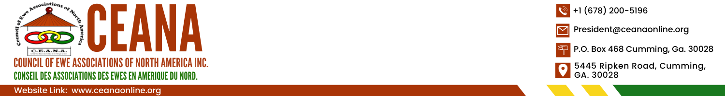
October 17, 2025

COMMUNIQUÉ

Council of Ewe Associations of North America (CEANA) Concludes Annual Convention in Dallas, Texas

Focus: Fundraising for Development Initiatives in Eweland

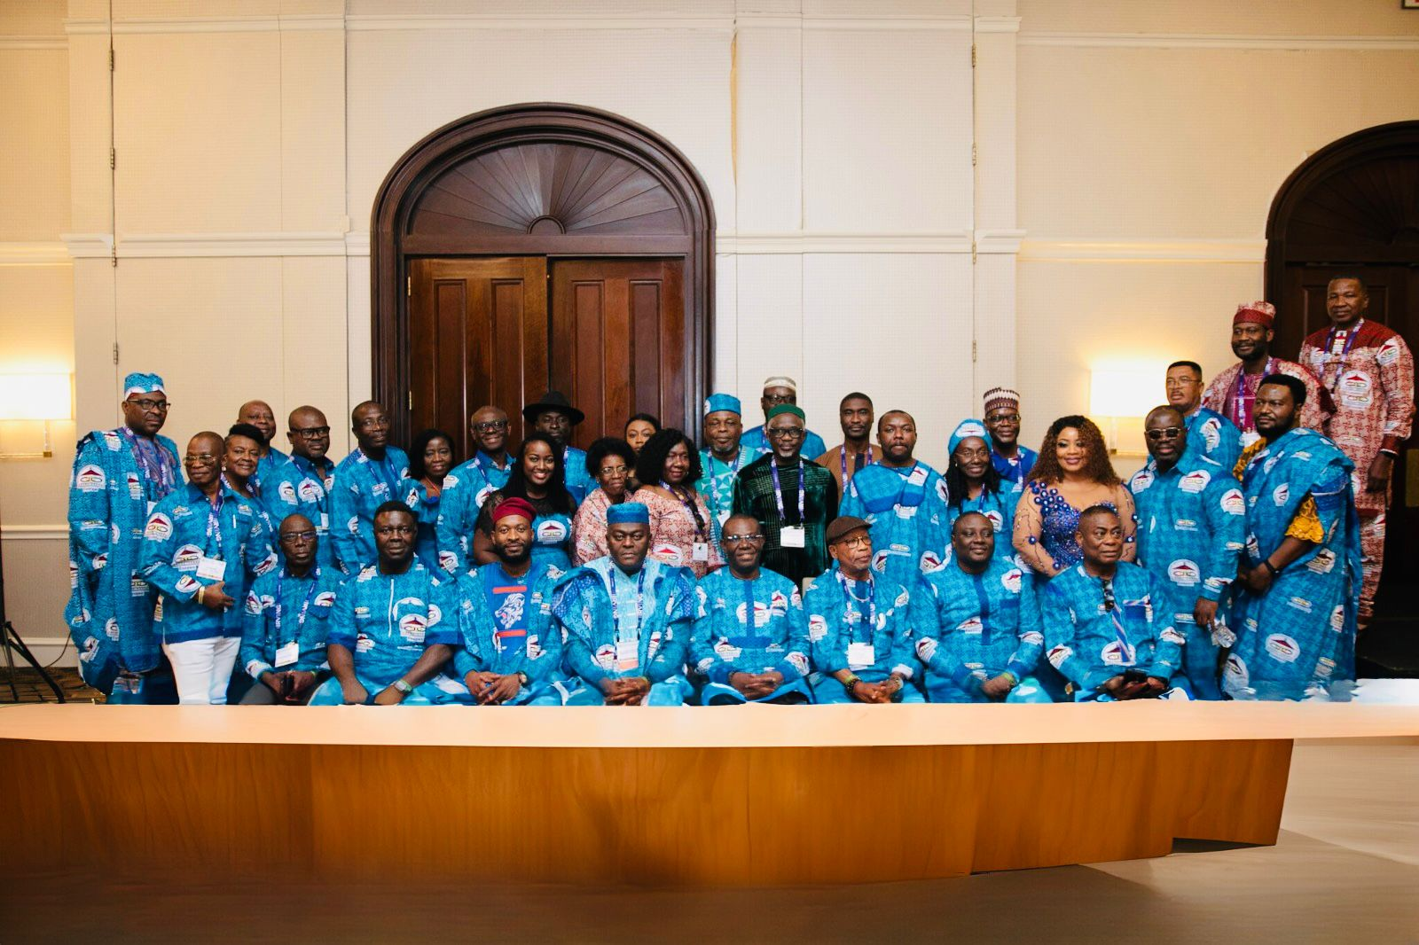

Dallas, Texas, USA, August 28-September 1, 2025. The Council of Ewe Associations of North America (CEANA) proudly announces the successful completion of its 32nd Annual Convention, from August 28 to September 1, 2025, at the Sheraton DFW Airport Hotel, Dallas, TX, under the theme “Our Health, Our Wealth”. This year’s Convention was hosted by the Ewe Association of Dallas, under the presidency of Mr. Winfred Gbedemah, with the assistance of his able executives and convention organizers. The event brought together Ewe communities from across the United States, Canada, Europe, Ghana, Togo, Benin, and Nigeria in a vibrant celebration of culture, unity, and purpose. The event was watched by people worldwide on social media outlets such as CEANA’s YouTube, Facebook, GhanaWeb, Ewe24, and other social media platforms. The main objective of the convention was to mobilize support and raise funds for the development of Eweland. There were series of cultural exhibitions, keynote addresses, and fundraising activities, CEANA reaffirmed its commitment to fostering sustainable development in the region.

The Guest of Honor, the Rt. The Honorable Alban Bagbin, Speaker of the Parliament of Ghana, was unable to attend in person, but he was represented by Hon. Rockson Nelson Kwame Etse Dafeamekpor, the Member of Parliament (MP) for South Dayi and Majority Chief Whip of Parliament. The Keynote Speaker was Dr. Kenneth Afenya, a nephrologist and the Medical Director at Lex Kidney Care, Lexington. Kentucky, United States.
On Thursday, August 28, attendees were treated to a Cowboys and Girls’ boogie night, mostly dressed in Cowboy and Cowgirl outfits, and danced to a selection of music all night long. The legendary Mr. Agboti Yawo made a surprise appearance, treating the audience to an electrifying performance. The youth and adults of the Ewe Association of Dallas also provided a spectacular performance and entertainment that garnered the admiration and appreciation of the banquet attendees. The attendees joined to dance our signature Agbadza Dance and Borborbor.

The Convention officially opened on Friday morning, August 29, with a meeting of the Council of Representatives (COR) board. Dr. Tsatsu E. Nyamadi, President of CEANA, chaired this meeting . The board also elected the following Executives for the 2025-2028 term:
• President – Mr. William Kumah
• 1st Vice President – Mrs. Penny Akpene Ametepi
• Director of Administration – Mr. David Abusah
• Secretary – Mr. Patrick Adzadu
• Assistant Secretary – Ms. Freda Mawuse Alormele
• Financial Controller – Mr. Francis Edem Katey
• Public Relations Officer – Ms. Mawusi Kudjawu

The Second Grand Durbar of Chiefs and Queen Mothers, a highly anticipated event, was held on Friday evening. The audience, comprising over 400 attendees, was enthralled by the rich display of royal regalia by both Traditional and Ceremonial Chiefs and the Queen Mothers. The Ewe Association of Dallas dance group's well-choreographed Ewe cultural performance was a highlight, and Mr. Agboti Yawo's vintage songs were met with resounding appreciation.

On Saturday morning, August 30, a procession of delegates and guests from the various Associations was ushered into the General Session of the Convention, amidst jubilation and celebration. Mr. Winfred Gbedemah, the Second Vice President of CEANA and President of the Ewe Association of Dallas, delivered the welcome address, assuring attendees of an exciting Convention. He acknowledged the hard work of Madam Esi Adoboe, the Vice President of Dallas, for her stewardship; Mr. Julius Korto for being a great Assistant Manager of the convention; and all the members of the planning committee, as well as all the numerous volunteers who worked and would still work hard to ensure a very successful convention. He thanked his wife, Mrs. Sasha Gbedemah, for supporting him throughout the planning stages.

The outgoing President of CEANA, Dr. Tsatsu Nyamadi, delivered the State of CEANA address. He congratulated all the 20 Ewe Associations on their unity, zeal, determination, and purpose, which have kept the CEANA organization alive and thriving for all these years. Dr. Nyamadi commended all the donors for their generosity, without which CEANA would not have been able to complete a Kindergarten building at Dodome-Awuaisu in Ghana and a Computer Library in Kpalime, Togo. He also announced that CEANA has been awarding scholarships (dating back to 2002) to students in Ghana, Togo, and Benin every year, with over 500 scholarships having been awarded to date. Dr. Nyamadi also informed the attendees that CEANA is embarking on the renovation of a Community Library at Anloga, a Medical Laboratory at Agotime Akpokope, and a Library Complex at Anfoeta-Tsibi, all in the Volta Region of Ghana. He urged everyone to donate generously toward this year’s fundraising to help CEANA continue the development of Eweland.

The Rt. Hon. Bagbin, speaking through Hon. Dafeamekpor, sent warm greetings and expressed his gratitude for the invitation. The Speaker commended the leadership of CEANA for leading the way in developments of Eweland, doing so with donations from individuals who contributed to CEANA. He wished all attendees well and a successful convention. Hon. Dafeamekpor continued by saying that CEANA could do more to promote its activities by engaging with other social media platforms, such as X (formerly Twitter), TikTok, Instagram, and others. Hon. Dafeamekpor also advised the CEANA leadership to consider launching the convention annually in Ghana, which could attract more Ghanaians to attend and help raise significantly more funds for the developmental projects earmarked. He also promised that a lot of Members of Parliament will attend the next convention, to be held in Washington, D.C., in 2026.

Others who spoke during the morning session included Hon. Bedzrah, MP for Ho West and Chairman of the Volta Regional Caucus in Parliament, Hon. Peter Nortsu-Kotoe, MP for North Akatsi, Hon. Phillis Naa Koryoo Okunor, MP for Awutu-Senya East, Hon. Kwame Dzudzorli Gakpey, MP for Keta, and Hon. Dr. Othniel Kwainoe, MP for Ekumfi, Hon. Daniel Agboka-Dzegede, Executive Director of Volta Development Forum (VDF) and the Regional Director of Ghana Investment and Promotion Center (GIPC) for the Volta and Oti Regions, and Dr. Kenneth Afenya.

The Saturday evening banquet is CEANA’s signature annual fundraiser and a showdown between the various CEANA affiliate organizations in what is known as the Associations’ Challenge. This year, the Ewe Association of Washington, D.C. proved to be a less significant challenge to the Ewe Association of Greater Boston. Greater Boston who won the Association Challenge for this year. United Volta Association of New York won second place, followed by the Ewe Association of Washington, D.C. Metro Inc., and then Norvisi Association of New Jersey. The rest of the Associations also donated handsomely to support CEANA’s aims and objectives of raising funds for developmental projects in Eweland. Several individuals and groups, such as Dekaworwor of Maryland and CEANA Nurses and Allied Health Workers, donated large sums of money to help CEANA’s fundraising efforts.

In his keynote address, Dr. Kenneth Afenya noted that he has not only accepted to be the keynote speaker, but also as a fellow member of the vibrant African family here in America, a family rooted in strength, resilience, and deep cultural pride. He acknowledged that the theme for the convention, “Our Health, Our Health,” is both timely and timeless. He advised that we need to look beyond the clinics and hospitals and be aware that social determinants shape our health. He also charged the attendees to challenge the narrative that success means sacrificing sleep, skipping meals, or ignoring stress. He strongly recommended that CEANA should advocate for policies that bring healthcare and resources to our communities. CEANA should also partner with schools, churches, and cultural groups to spread awareness and support one another in navigating systems that were designed with us in mind.

In his end-of-term address, Dr. Nyamadi thanked CEANA member associations for allowing him to serve them for two terms as President. He congratulated the newly elected CEANA Executives. He noted that under his leadership, the state of CEANA is very sound; CEANA has accomplished a great deal but can do more, the organization is on solid ground, and the future of CEANA is bright. He wished the incoming executives and the newly elected President, Mr. William Kumah, well and that they can always count on his support and that of all the other leaders before him. Dr. Nyamadi also thanked his wife, Mrs. Patience Nyamadi, for supporting him throughout these nine years, first as Vice and later as President. He noted that it had not been easy, but she stood by him throughout. He shared the following quotes with the attendees: "Alone we can do so little; together we can do so much." (Helen Keller); "We cannot seek achievement for ourselves and forget about progress and prosperity for our community." (Horace Mann); and "The greatness of a community is most accurately measured by the compassionate actions of its members." (Coretta Scott King); and "If you want to go quickly, go alone. If you want to go far, go together." (Unknown)

The Youth and Adults of the Ewe Association of Dallas also entertained the audience during the dinner dance. The legendary Agboti Yawo also treated the crowd to non-stop dancing music, to the admiration of all attendees and many viewers who watched live on CEANA's YouTube and Facebook pages, as well as on Ghanaweb, Ewe24, Afenya Media, and other social media handles. The evening was concluded with the awarding of plagues, the swearing-in of the elected executives into office, and the official transfer of the mandate to host the CEANA Convention's symbolic Stool to the Ewe Association of Washington, D.C., Metro Area Inc., as the host of the 2026 Convention.

A well-attended non-denominational church service was held on Sunday morning. The service was officiated by a team of clergy led by Rev. Martin Osae of the Ghanaian Community Presbyterian Church USA in Irving. Prof. Samuel Nyamuame of Binghamton University led the group of instrumentalists in worship.
In the afternoon, the Convention guests converged at the CEANA Convention Cookout, which featured dishes from Eweland, accompanied by Agbadza, Ewe Highlife, and Borborbor tunes. Sunday evening was capped off with another signature event – “Mise Gli Loo – Toli Night,” a rendition of a cultural pastime: evening storytelling.

On Monday, September 1, 2025, Convention delegates and guests departed to their various home destinations across North America, Ghana, Togo, Benin, and Europe with a renewed sense of unity, friendship, and purpose.
Mr. Steve Dei, the outgoing CEANA PRO, was the Master of Ceremonies and was assisted by Ms. Empress Mawusi Kudjawu, the newly elected PRO and co-host of the CEANA Central Talk Show. CEANA Media, led by Dr. Edem Wornyo, provided live streaming for the event. Authentic Mama Emefa, a Radio host of Dunenyo Borborbor Show on Top Radio 103.5 FM in Ghana, was in attendance to cover the events live. Video and photography coverage was provided by Sankofaonline Media from Chicago. Chatting with Nicole was also in attendance to support the convention.

Highlights of the Convention Include:
- Successful fundraising efforts aimed at supporting education, healthcare, and infrastructure projects in Eweland.
- Strengthening of partnerships between diaspora organizations and local development stakeholders.
- Cultural showcases that celebrated the rich heritage and traditions of the Ewe people.
CEANA extends its heartfelt gratitude to all attendees, donors, and volunteers whose contributions made this event a resounding success. Together, we continue to build bridges between the diaspora and our homeland, fostering progress and preserving our rich cultural legacy.

For more information about CEANA and its development initiatives, please contact:
Mr. William Kumah, President of CEANA, president@ceanaonline.org, www.ecanaonline.org

Issued by CEANA secretariat

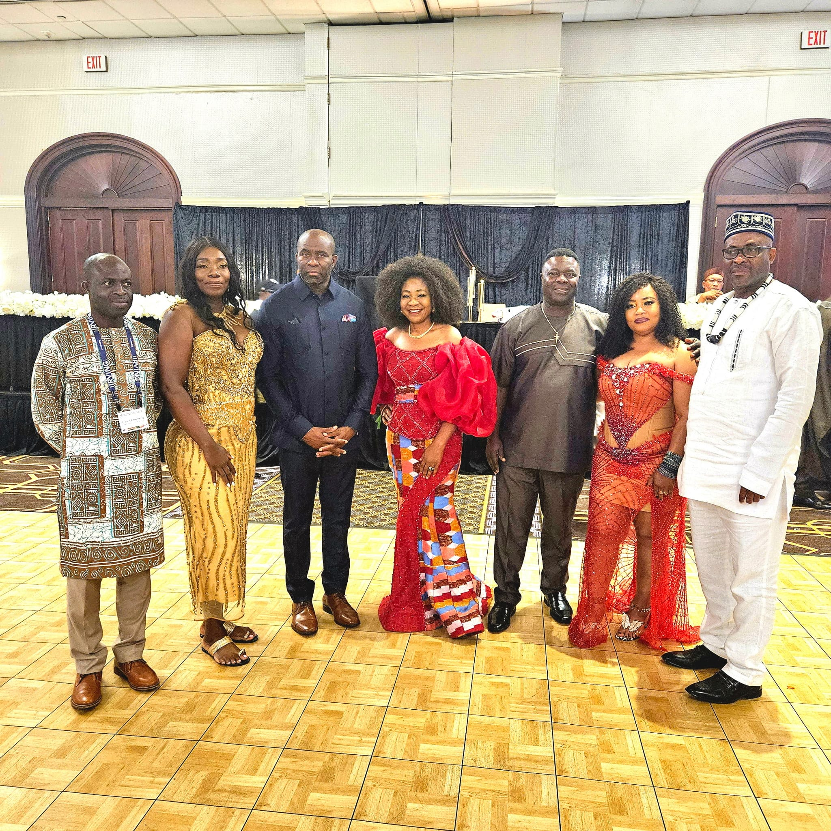

New CEANA Executives
Invited guests with president of CEANA and other leaders

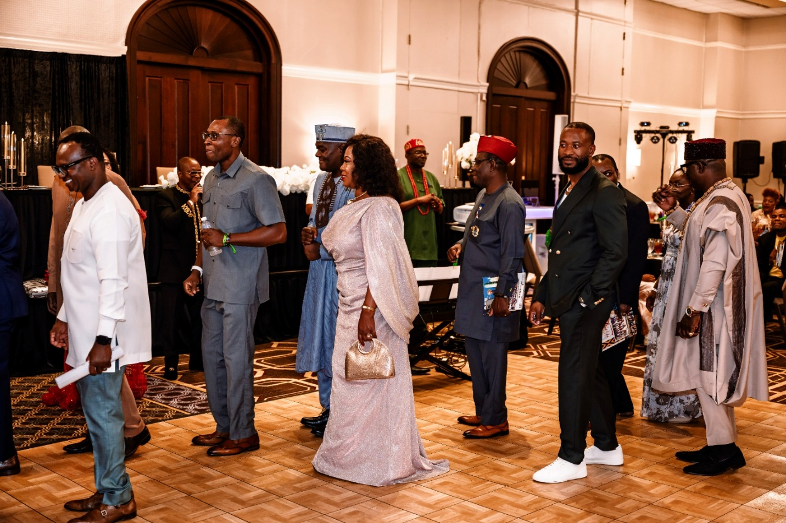
Procession to Saturday evening dinner dance
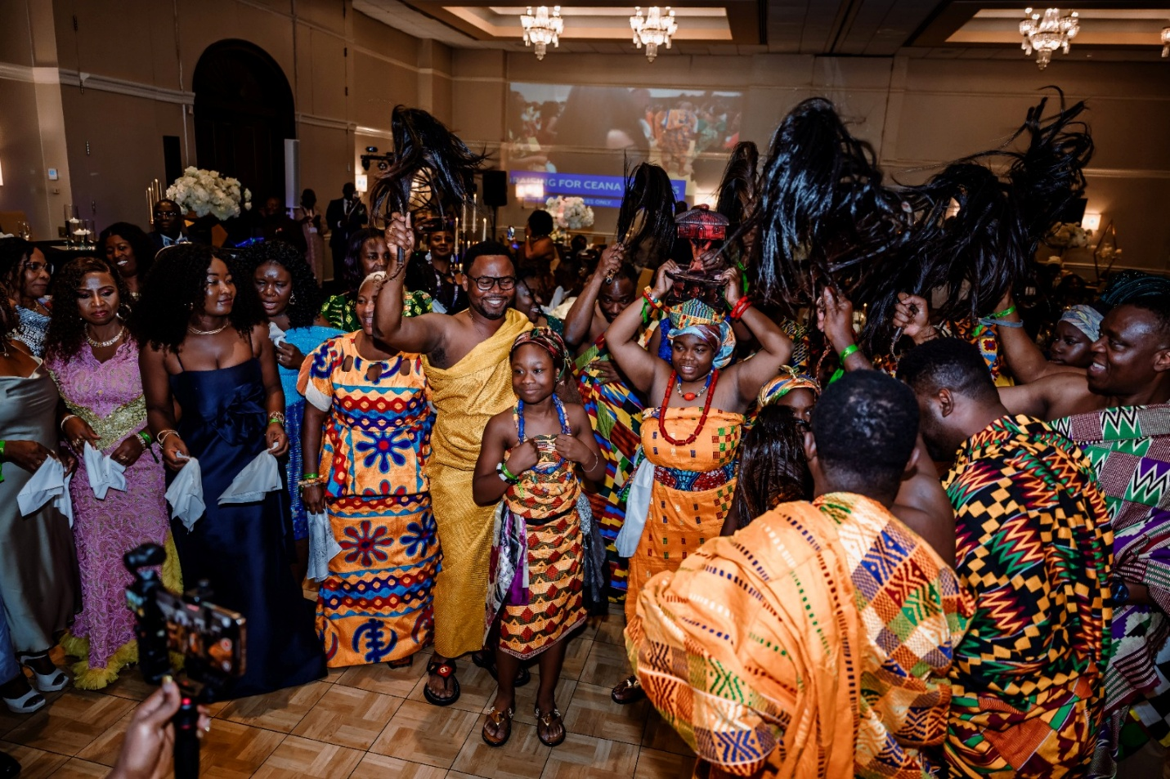
Procession to CEANA convention host handover

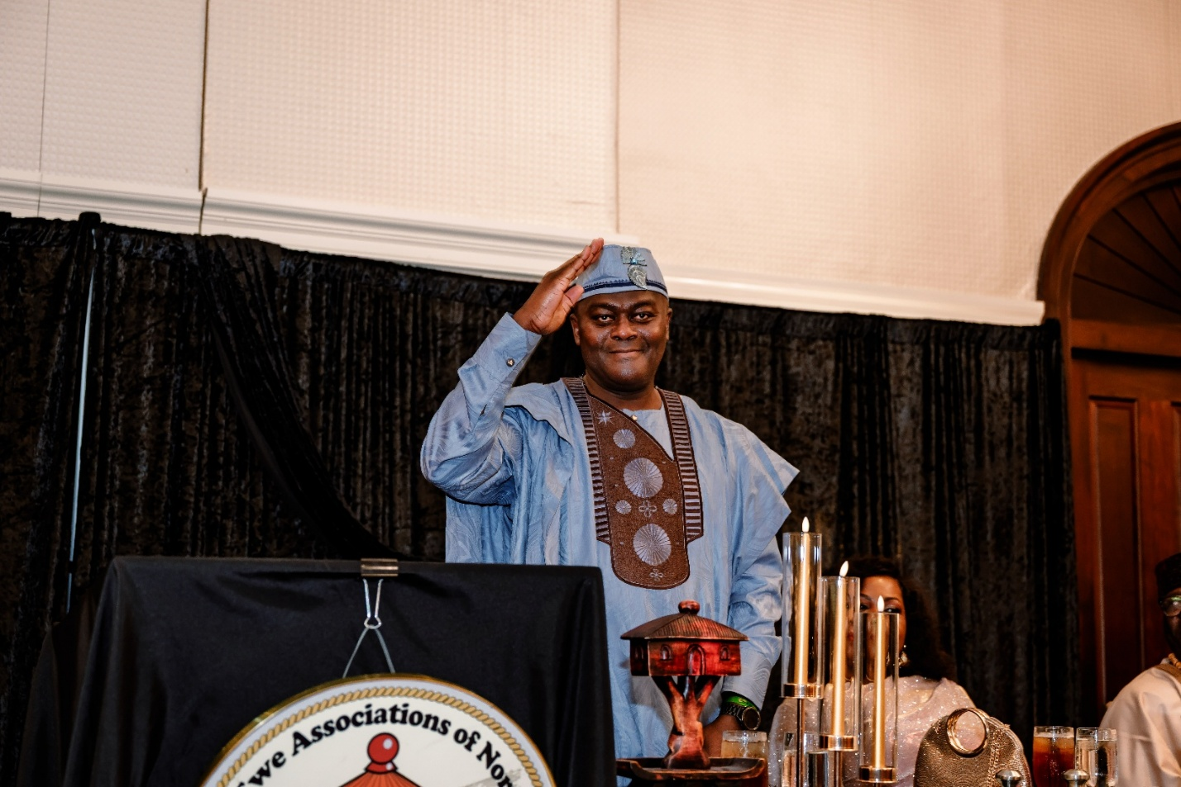
Former president Dr. Tsatsu E. Nyamadi saluting the crowd after his final speech
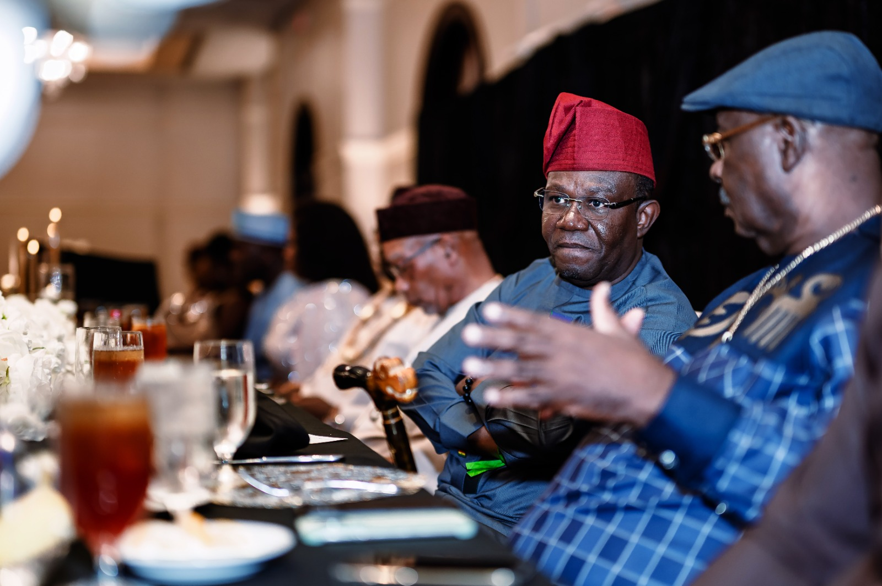
Leaders of Ewe Community having discussion

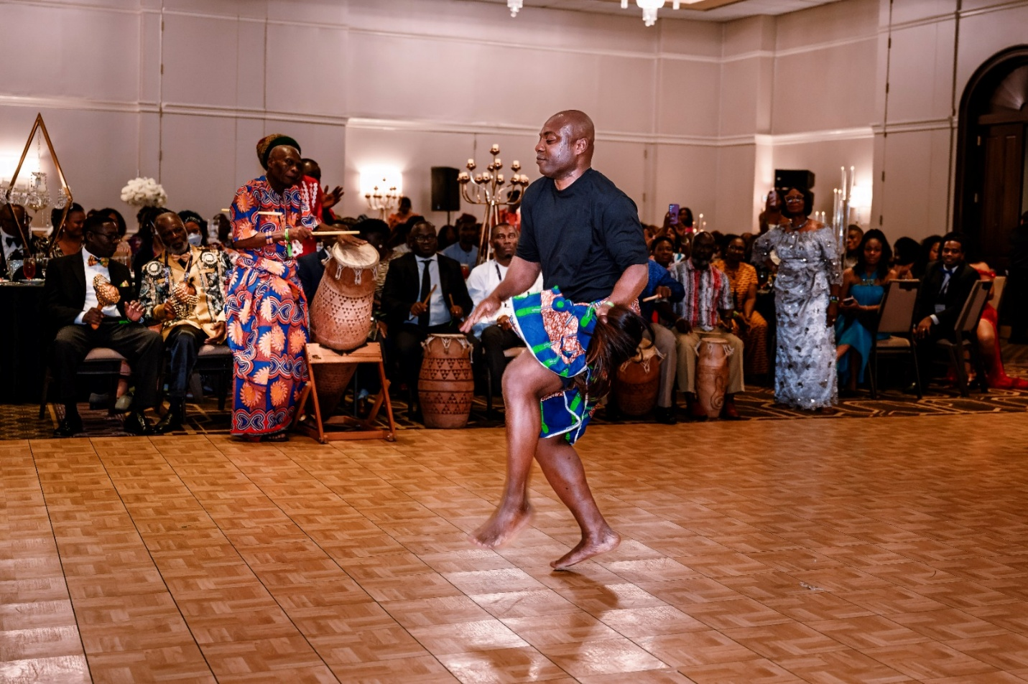
Professor Elikem Nyamuame performing the …. dance, with Torgbui Foli Amanyo III (Professor Gideon Alorwoyie) on the big drum.
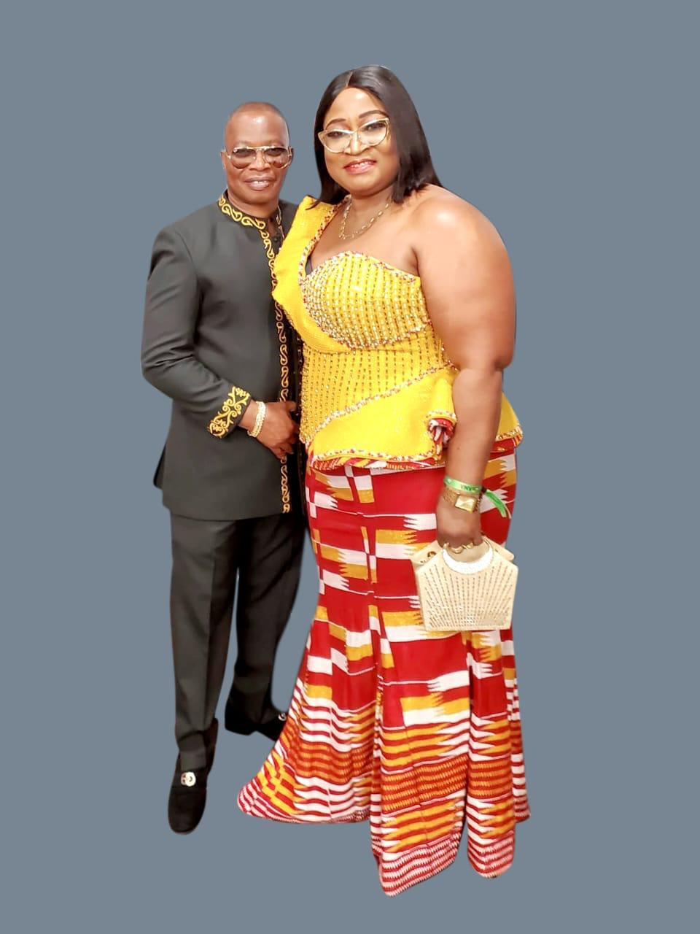
Former CEANA PRO Mr. Steve Dei on the floor with his wife Mrs. Vivian Newman-Dei

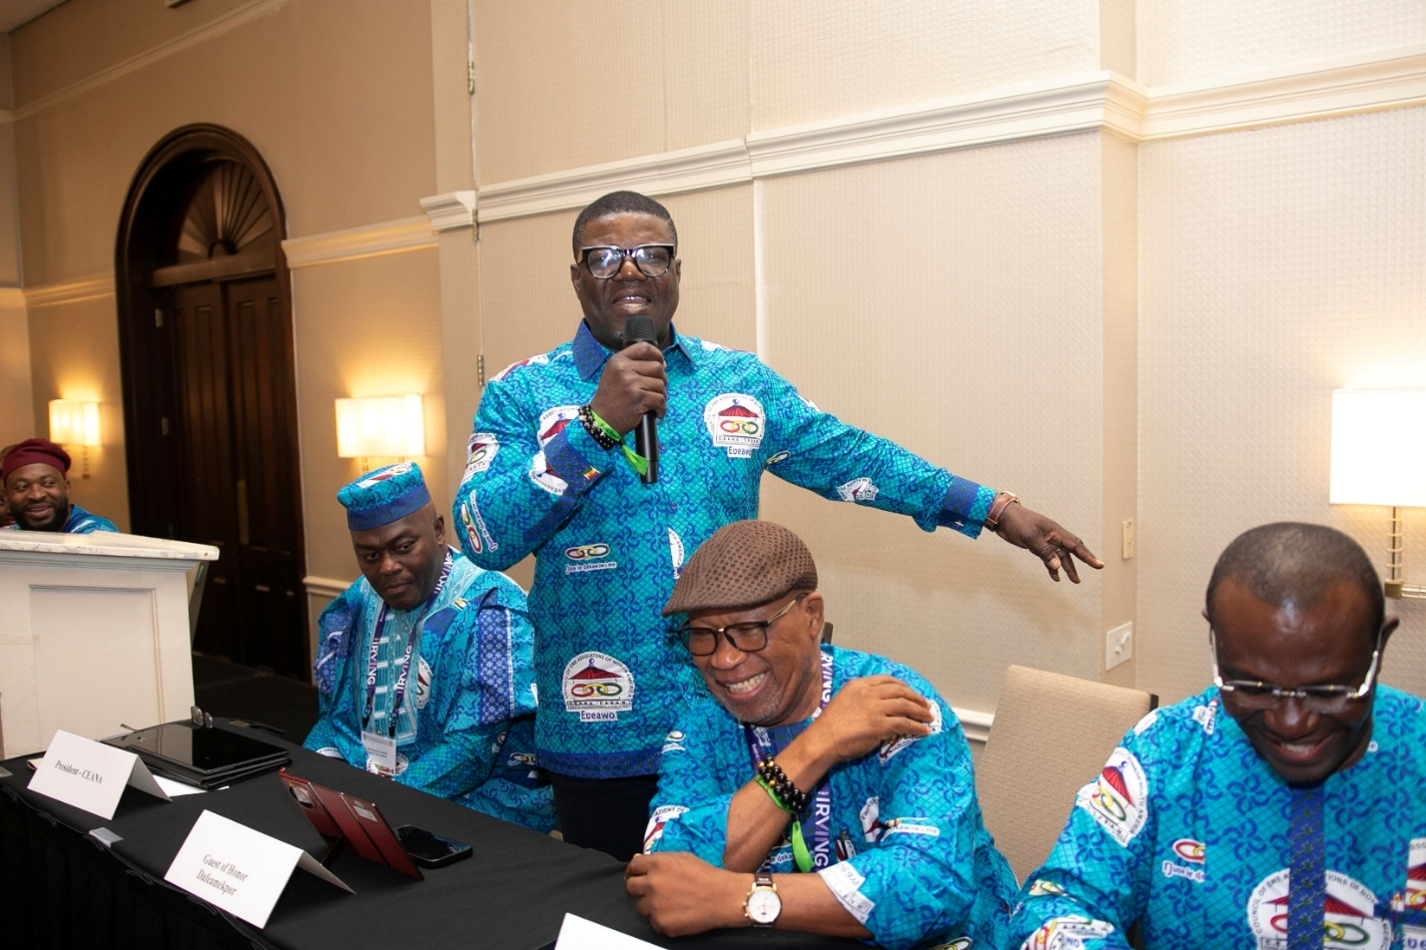

Leader of parliamentary delegation Honorable Dafeamekpor speaking to the crowd
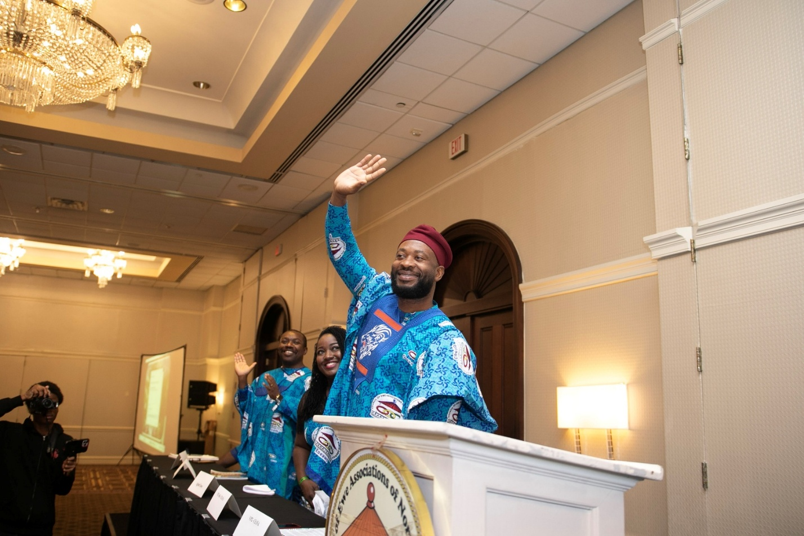
President of Ewe Association of Dallas Mr Winfred Gbedemah waving to the crowd

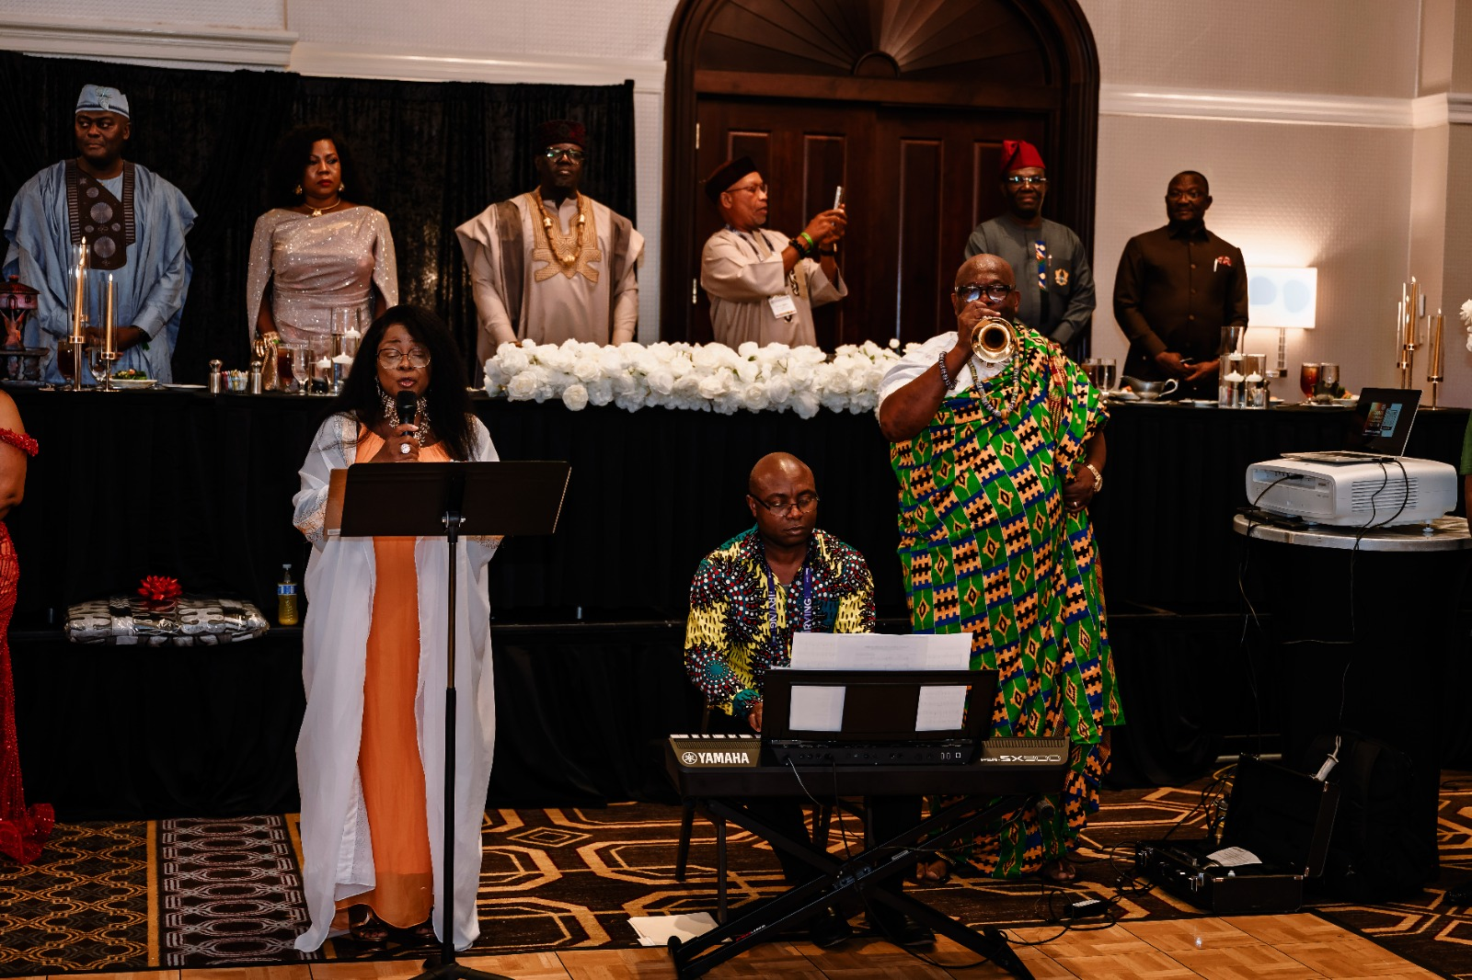

Sunday Church service



