🔴 Academic Crime of Global Proportions: GCTU’s Integrity Crisis which Painted Ghana as a hub for fraudulent research and Damaged trust in African scholarship globally.

Vice-Chancellor of GCTU, Pioneer of “20 by 30” vision
The Ghana Communication Technology University (GCTU) is under severe global scrutiny following revelations of academic dishonesty and fraud by its top academic staff, leading to multiple paper retractions from reputable journals. This scandal tarnishes not only GCTU’s reputation but also places Ghana’s entire academic sector on a dangerous global blacklist.
The Ghana Communication Technology University (GCTU) has committed what is being described as a global academic crime, with serious implications for its leadership and Ghana’s educational credibility. Multiple professors are implicated in academic dishonesty and fraud, leading to paper retractions by top international journals.
Prominent global universities including MIT, Harvard, Oxford, University of Pretoria, and Cambridge etc now flag these publications with warnings to researchers worldwide not to use or cite them. The implications are devastating for Ghana’s knowledge credibility, academic diplomacy, and future partnerships.
This scandal has resulted in international academic databases including MIT, Harvard, Oxford, University of Pretoria, and Cambridge etc flagging GCTU publications with warnings to researchers worldwide not to use or cite them. Such a situation is catastrophic for Ghana’s academic sector, undermining decades of hard-won scholarly credibility.
Instead of fulfilling the “20 by 30” vision to place GCTU and Ghana on the global academic map positively, the university now stands out as one of the leading institutions associated with fraudulent publications.
🔻 Key Individuals Implicated
- Prof. Michael Nana Owusu-Akomeah – Dean of Students Affairs


- Emmanuel Attah Kumah Amponsah – Senior Lecturer and Head of Accounting, Banking and Finance
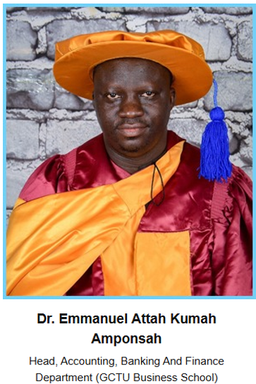

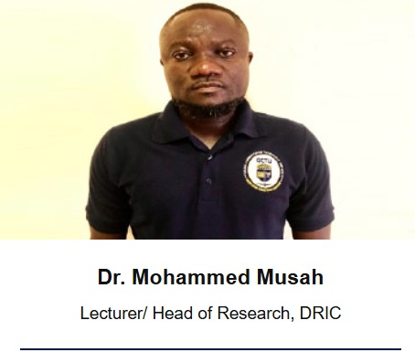
- Dr. Mohammed Musah – Lecturer and Head of Research, DRIC

And Others from other institutions in the country.

These retractions cite reasons such as:
- Fake peer review
- Computer-generated content
- Inappropriate referencing
- Unreliable results and conclusions

🔻 Statutory Violations
These actions breach the GCTU Basic Laws, which clearly state:
- The Dean, Director, or Head of Department may be relieved of their post by Council on grounds of incapacity, persistent absence without justification, conviction of a criminal offence involving dishonesty, fraud, or moral turpitude, or for gross misconduct.
- Academic Offences (Statute 58.1.g): Engaging in any form of academic cheating, dishonesty, misconduct, fraud, or misrepresentation to obtain academic credit or advantage is an offence.
- The Dean of Student Affairs may also be removed by Council for good cause, including gross misconduct or fraudulent acts, which now threaten the validity of his Associate Professorship due to retracted papers forming part of his promotion dossier.
These acts violate GCTU’s Basic Laws, specifically statutes on academic cheating, dishonesty, fraud, and gross misconduct, all grounds for dismissal and revocation of academic ranks and positions. The retracted papers also risk invalidating their past promotions and appointments.
🔻 The Bigger Picture
Instead of the Vice Chancellor’s touted “20 by 30” vision placing GCTU and Ghana on the world academic map, these events have rather:
- Painted Ghana as a hub for fraudulent research
- Damaged trust in African scholarship globally
- Triggered bans and citations blacklists by leading academic databases
🔻 Call to Action
GCTU Council, Ghana Tertiary Education Commission (GTEC), and the Ministry of Education must:
- Act decisively to protect Ghana’s academic reputation.
- Initiate disciplinary proceedings against the implicated staff.
- Issue a public apology and undertake institutional reforms.
- Reassess all promotions based on retracted publications.
- Reassess recent promotions by University and Appointments Committee-UAPC of GCTU
Ghana’s educational sector cannot afford silence on this global academic crime. It is time for truth, accountability, and decisive leadership to salvage what remains of our academic integrity.

🔻 Urgent Institutional Imperative
With authors engaging in dishonest and fraudulent publications – one of the highest crimes in academia – immediate action is non-negotiable. Failure to act decisively risks cementing Ghana’s reputation as a hub for academic fraud rather than innovation and excellence.

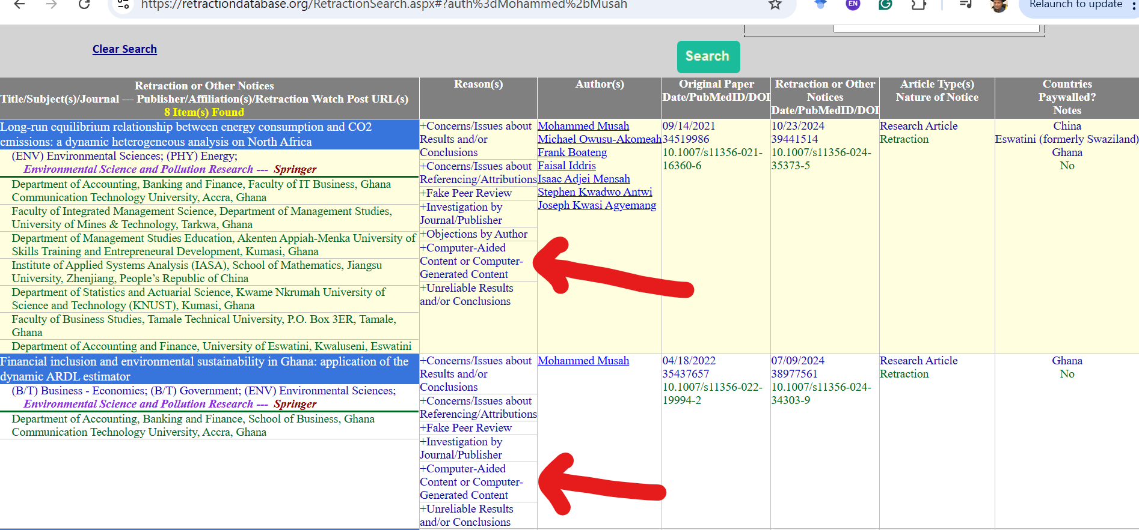
https://retractiondatabase.org/RetractionSearch.aspx#?auth%3dMohammed%2bMusah

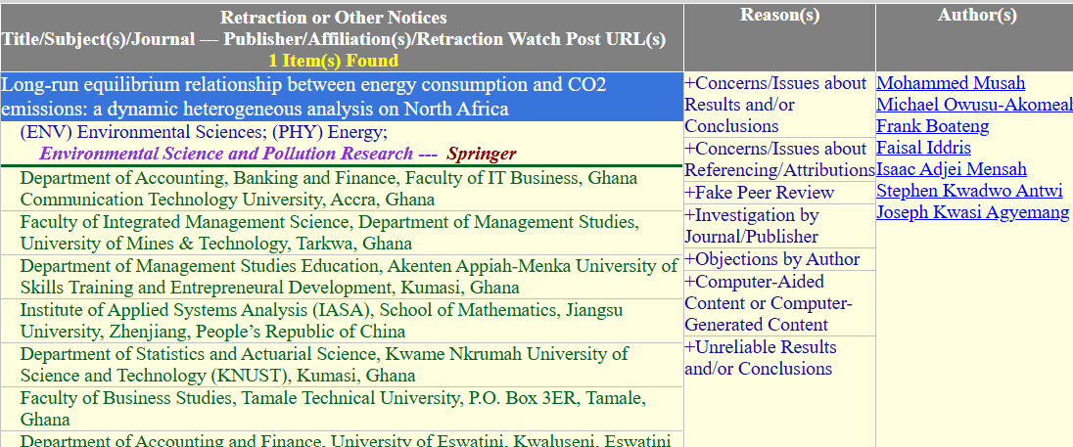

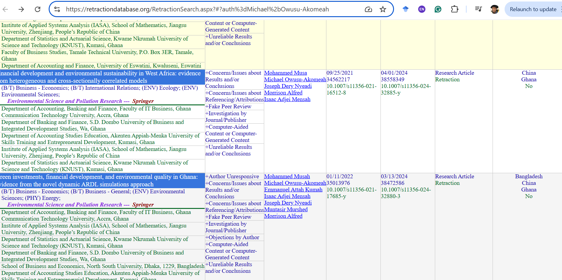

https://retractiondatabase.org/RetractionSearch.aspx?#?auth%3dMichael%2bOwusu-Akomeah
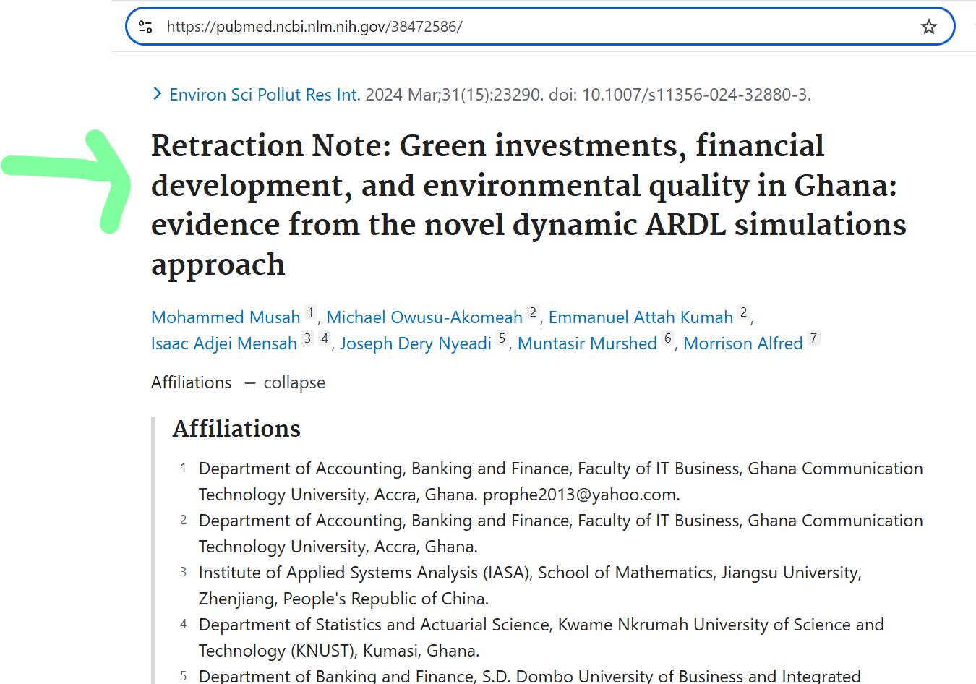

https://pubmed.ncbi.nlm.nih.gov/38472586/
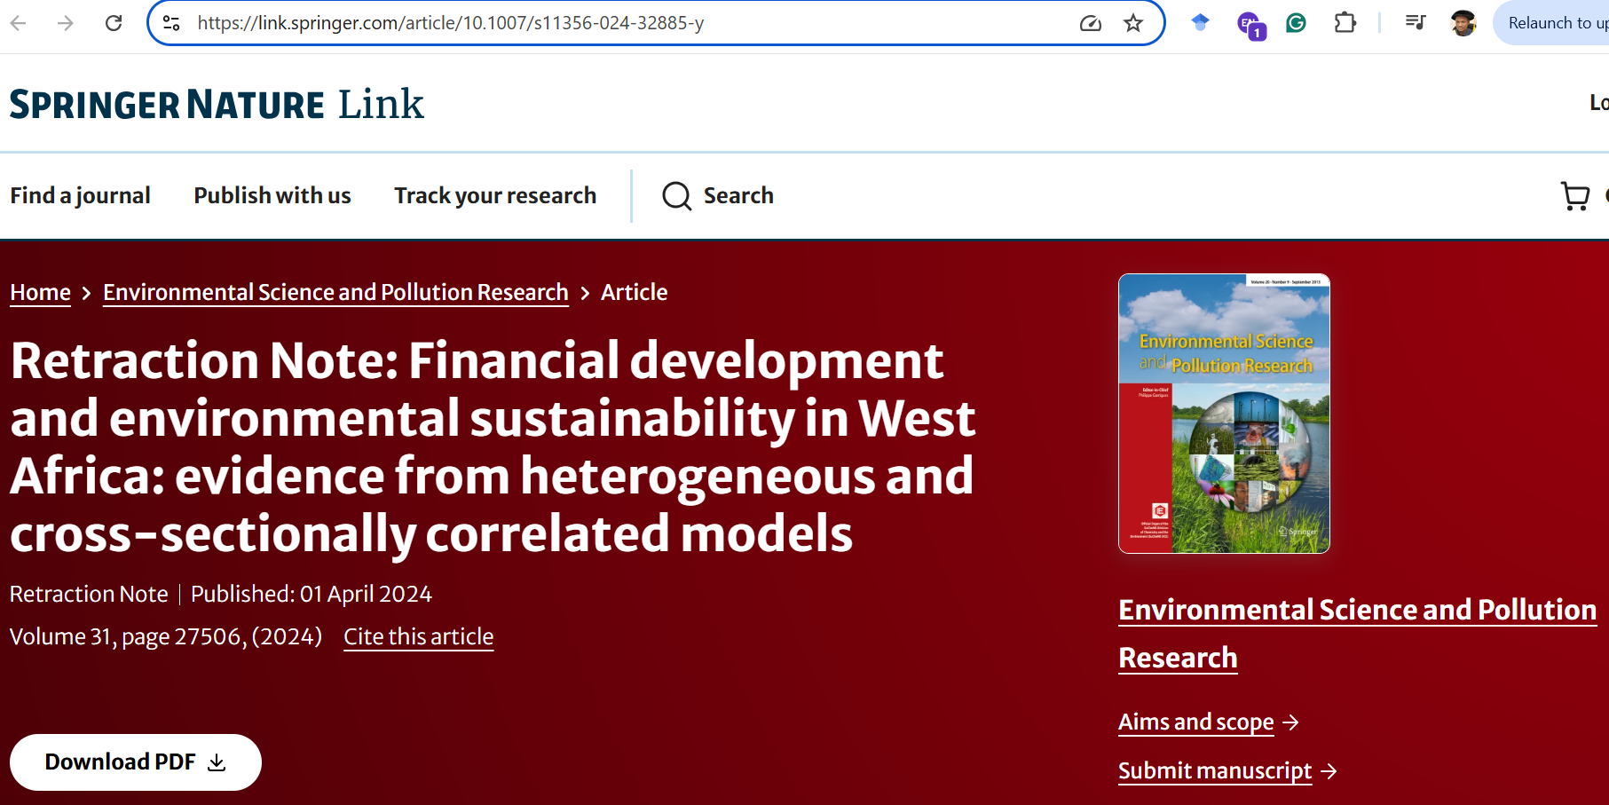
https://link.springer.com/article/10.1007/s11356-024-32885-y

https://doi.org/10.1007/s11356-021-16512-8
The Publisher has retracted this article in agreement with the Editor-in-Chief. An investigation by the publisher found a number of articles, including this one, with a number of concerns, including but not limited to compromised peer review process, inappropriate or irrelevant references, containing nonstandard phrases or not being in scope of the journal. Based on the investigation's findings the publisher, in consultation with the Editor-in-Chief therefore no longer has confidence in the results and conclusions of this article.

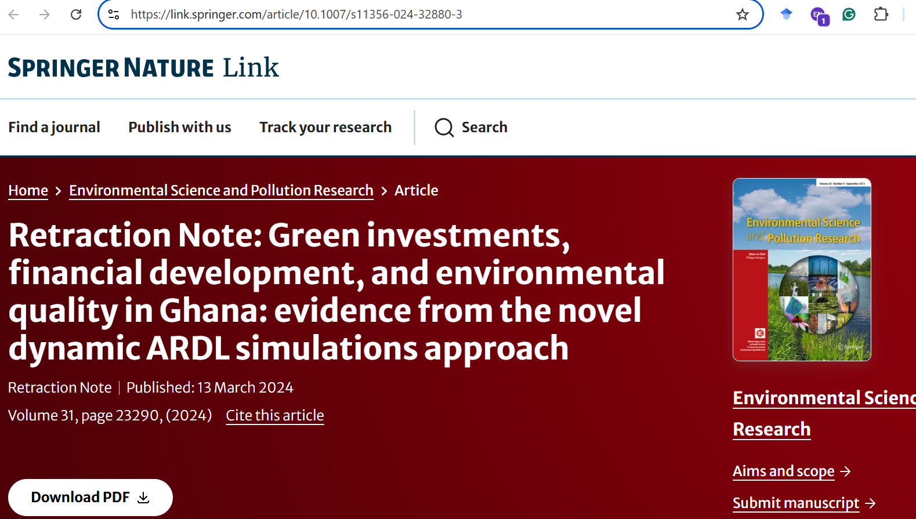

https://link.springer.com/article/10.1007/s11356-024-32880-3
https://doi.org/10.1007/s11356-021-17685-y
The Publisher has retracted this article in agreement with the Editor-in-Chief. An investigation by the publisher found a number of articles, including this one, with a number of concerns, including but not limited to compromised peer review process, inappropriate or irrelevant references, containing nonstandard phrases or not being in scope of the journal. Based on the investigation's findings the publisher, in consultation with the Editor-in-Chief therefore no longer has confidence in the results and conclusions of this article.
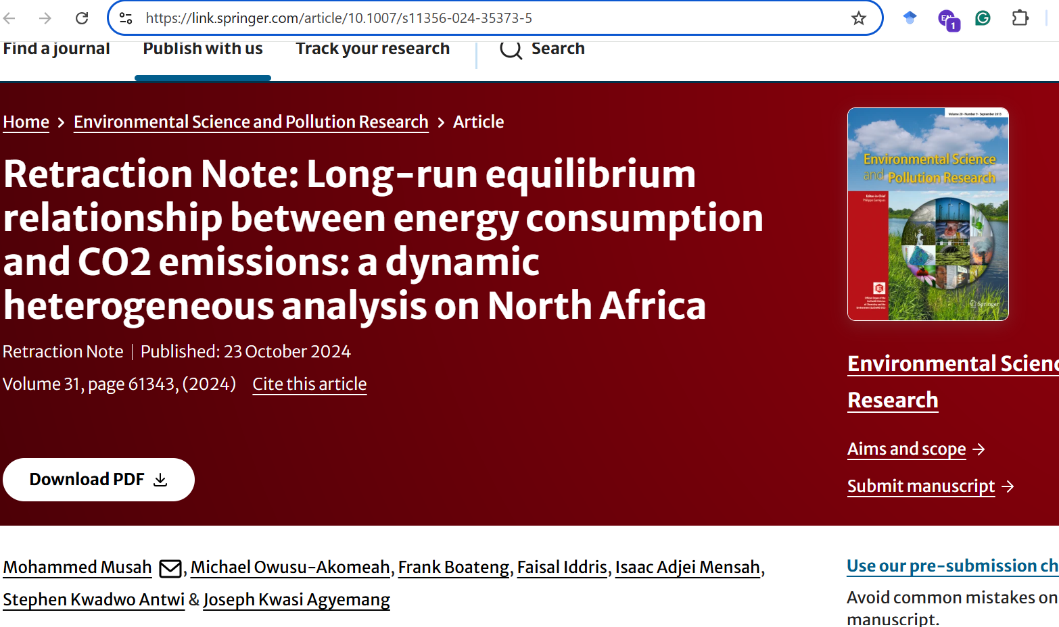

https://link.springer.com/article/10.1007/s11356-024-35373-5

https://doi.org/10.1007/s11356-021-16360-6
The Publisher has retracted this article in agreement with the Editor-in-Chief. An investigation by the publisher found a number of articles, including this one, with a number of concerns, including but not limited to compromised peer review process, inappropriate or irrelevant references, containing nonstandard phrases or not being in scope of the journal. Based on the investigation's findings the publisher, in consultation with the Editor-in-Chief therefore no longer has confidence in the results and conclusions of this article.

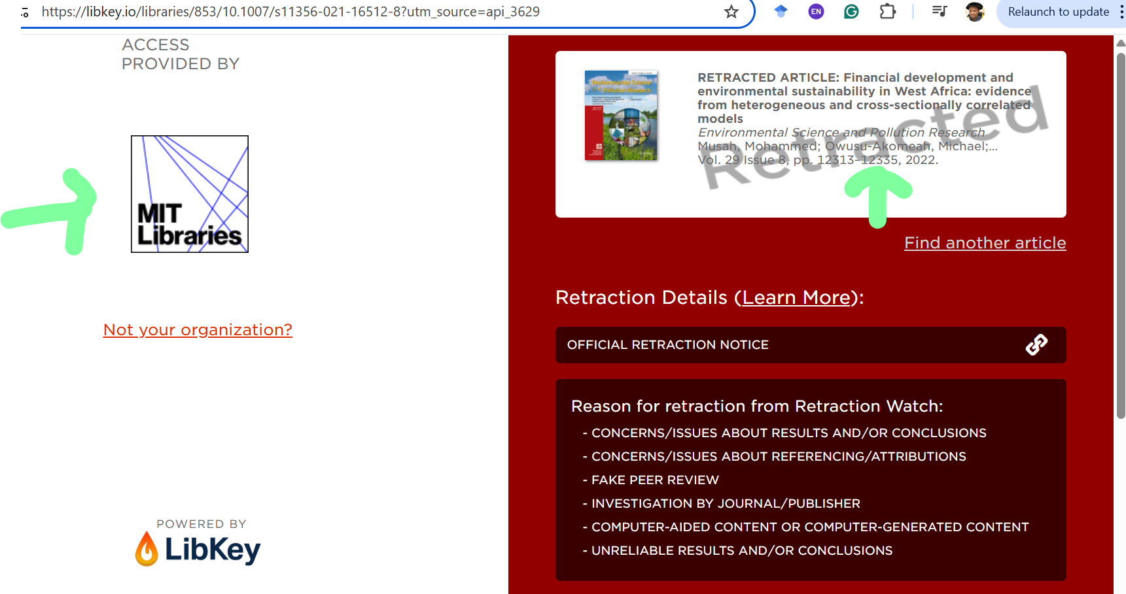
https://libkey.io/libraries/853/10.1007/s11356-021-16512-8?utm_source=api_3629
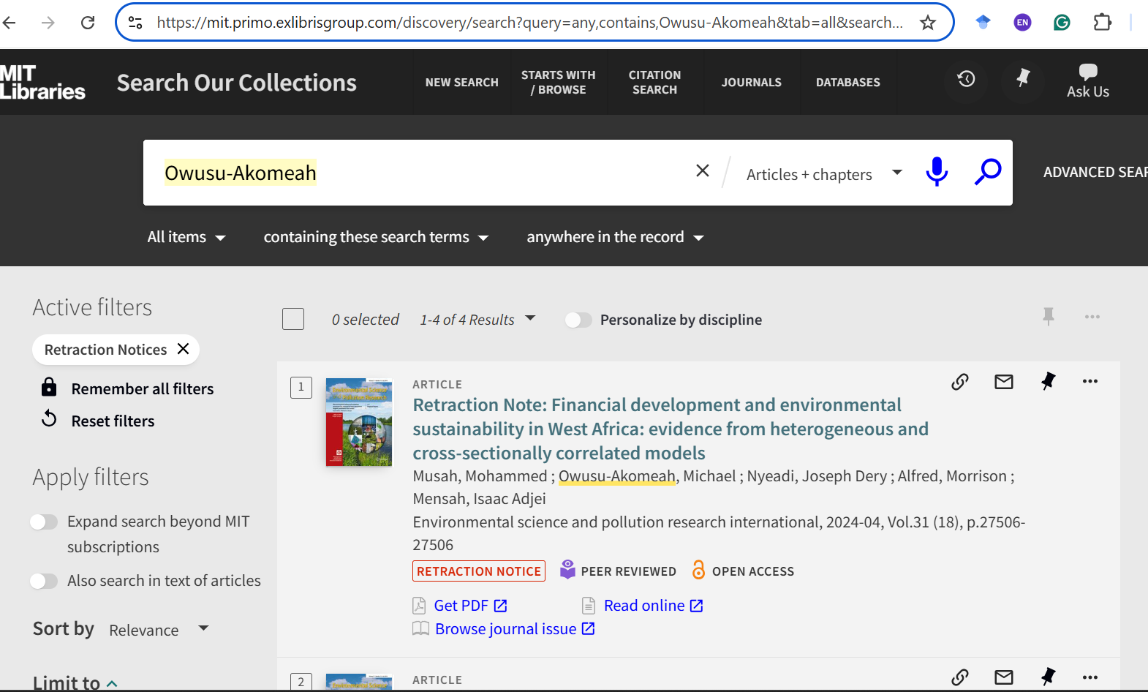
https://mit.primo.exlibrisgroup.com/discovery/search?query=any,contains,Owusu-Akomeah&tab=all&search_scope=cdi&vid=01MIT_INST:MIT&facet=rtype,include,retraction_notice&offset=0

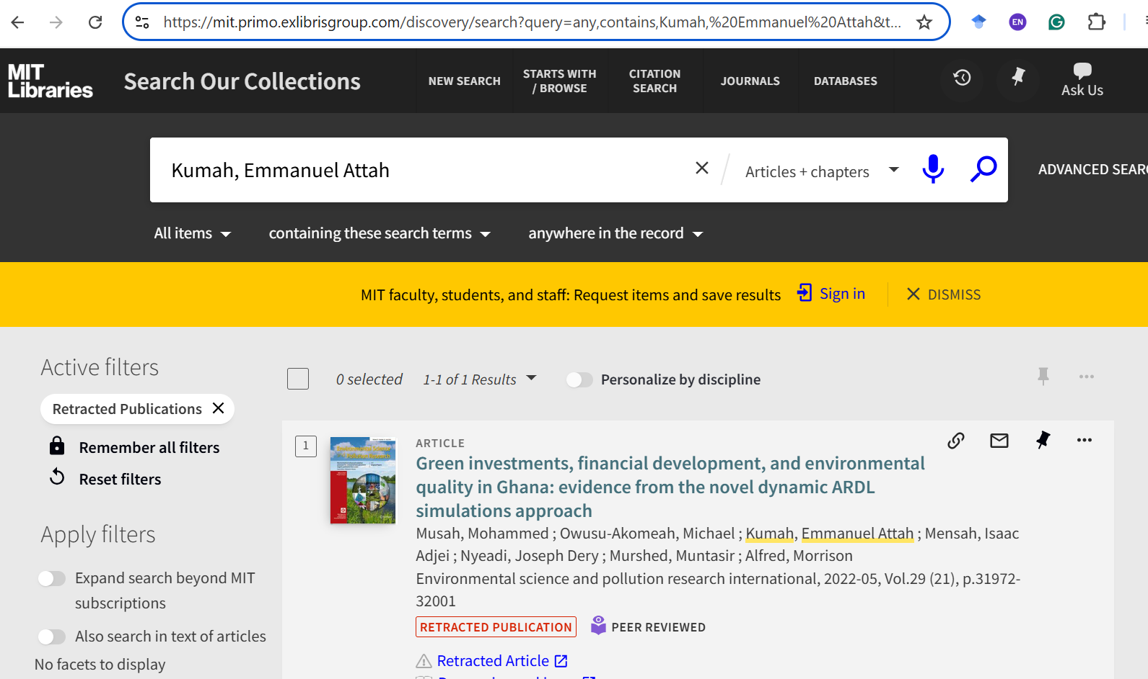
https://mit.primo.exlibrisgroup.com/discovery/search?query=any,contains,Kumah,%20Emmanuel%20Attah&tab=all&search_scope=cdi&vid=01MIT_INST:MIT&facet=rtype,include,retracted_publication&offset=0
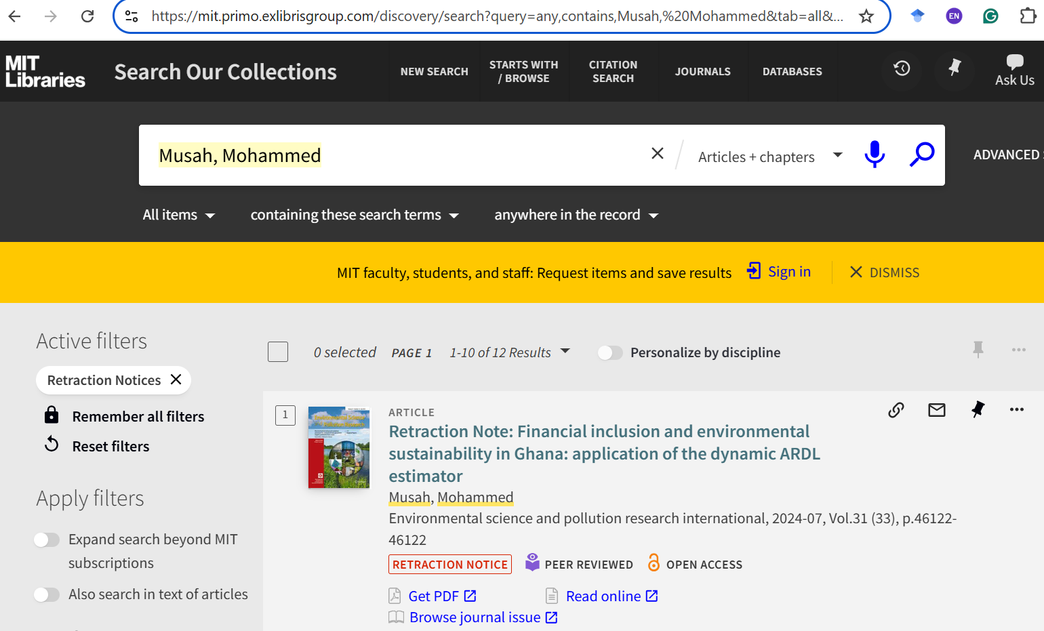
https://mit.primo.exlibrisgroup.com/discovery/search?query=any,contains,Musah,%20Mohammed&tab=all&search_scope=cdi&vid=01MIT_INST:MIT&facet=rtype,include,retraction_notice&offset=0&came_from=pagination_2_1

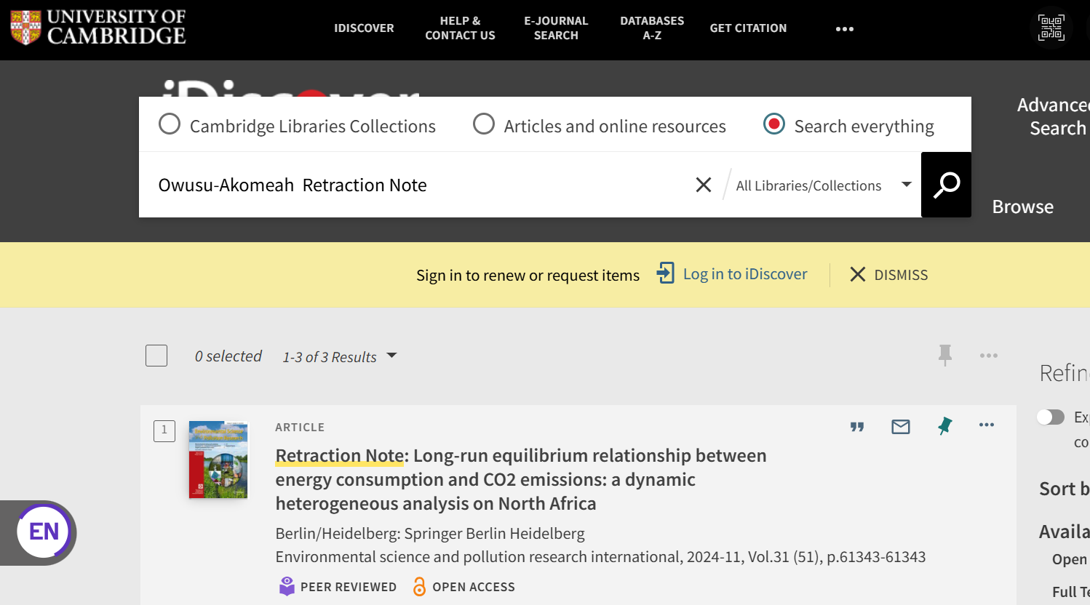
https://idiscover.lib.cam.ac.uk/primo-explore/search?query=any,contains,Owusu-Akomeah%20%20Retraction%20Note&tab=default_tab&search_scope=default_scope&vid=44CAM_PROD&lang=en_US&offset=0
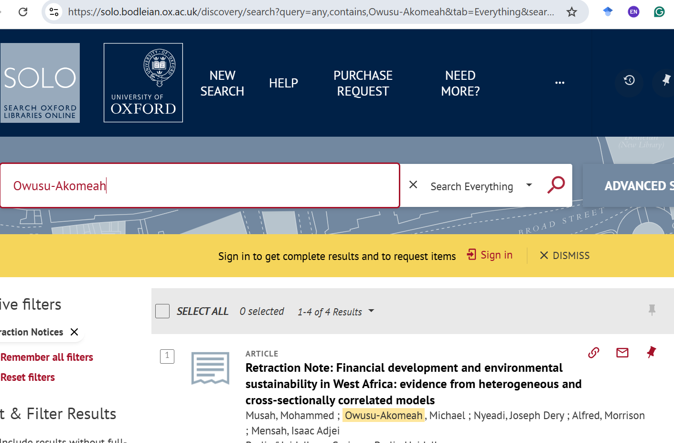
https://solo.bodleian.ox.ac.uk/discovery/search?query=any,contains,Owusu-Akomeah&tab=Everything&search_scope=MyInst_and_CI&vid=44OXF_INST:SOLO&facet=rtype,include,retraction_notice&offset=0
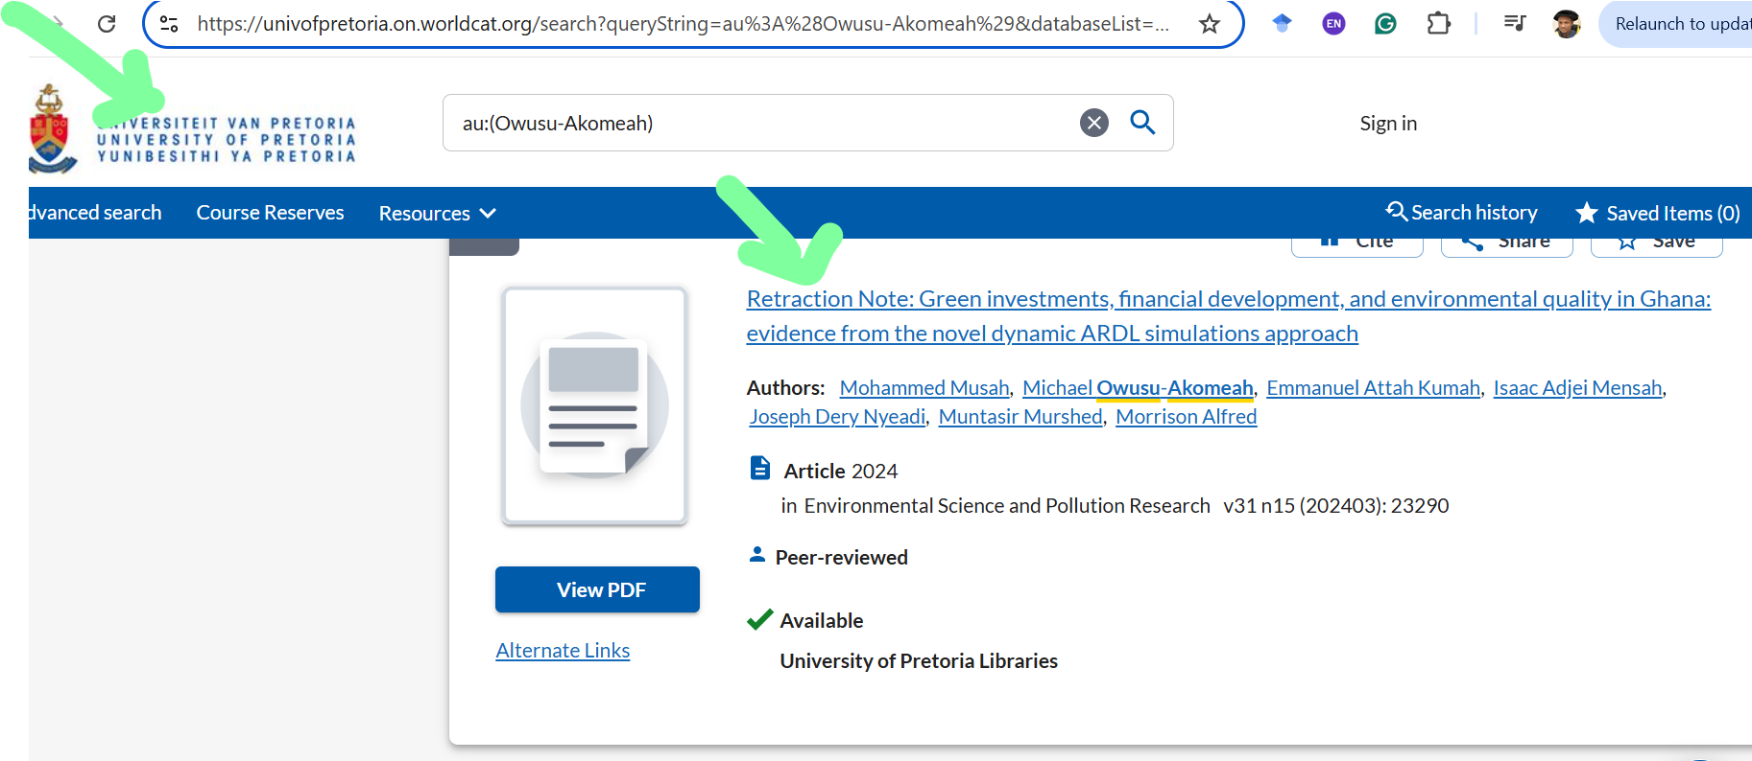
https://univofpretoria.on.worldcat.org/search?queryString=au%3A%28Owusu-Akomeah%29&databaseList=283%2C638&sortKey=BEST_MATCH&clusterResults=true&groupVariantRecords=false&bookReviews=off&page=2
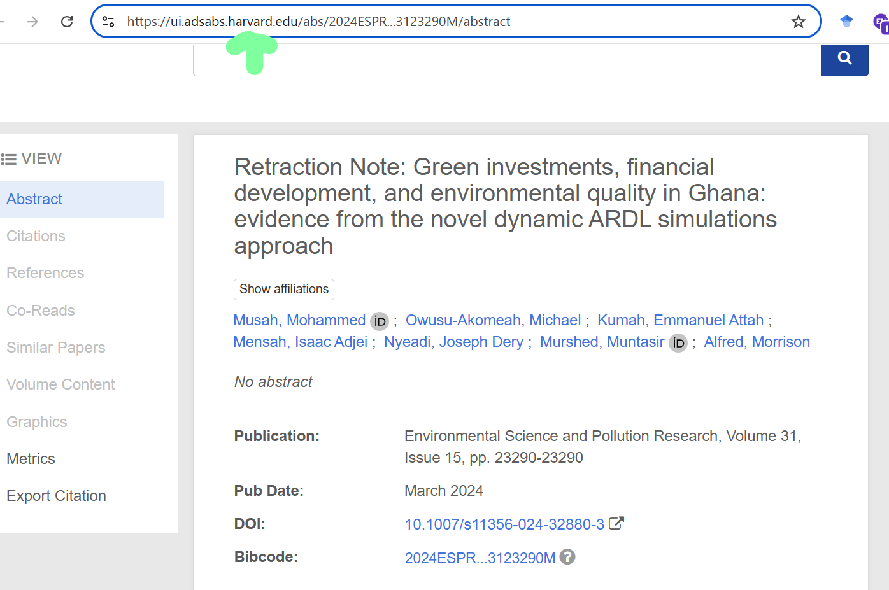

https://ui.adsabs.harvard.edu/abs/2024ESPR...3123290M/abstract

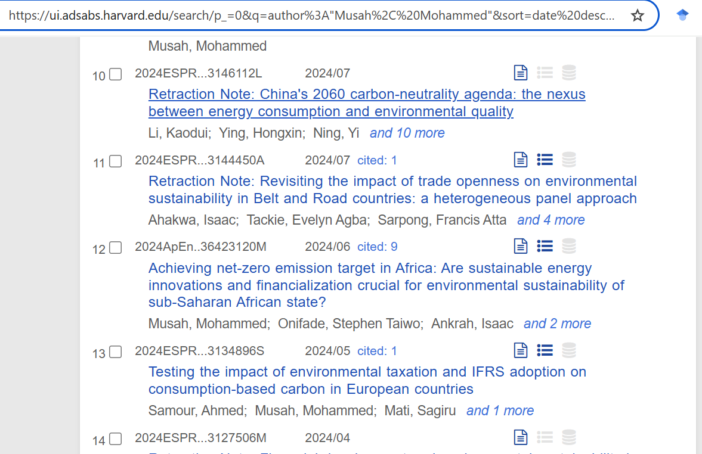
https://ui.adsabs.harvard.edu/search/p_=0&q=author%3A%22Musah%2C%20Mohammed%22&sort=date%20desc%2C%20bibcode%20desc
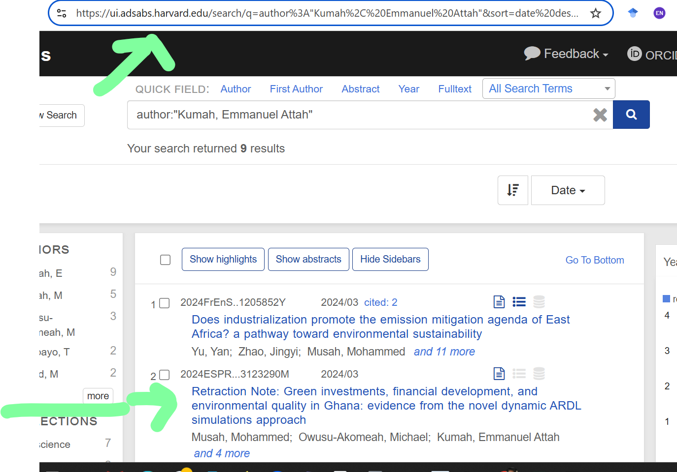
https://ui.adsabs.harvard.edu/search/q=author%3A%22Kumah%2C%20Emmanuel%20Attah%22&sort=date%20desc%2C%20bibcode%20desc&p_=0
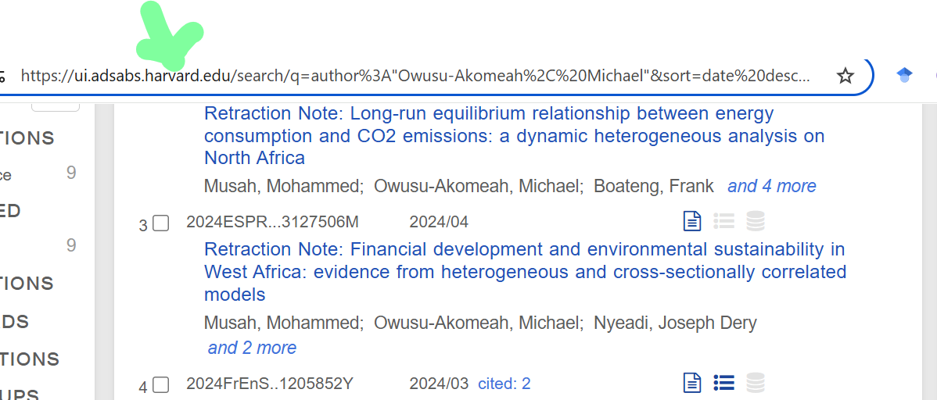

https://ui.adsabs.harvard.edu/search/q=author%3A%22Owusu-Akomeah%2C%20Michael%22&sort=date%20desc%2C%20bibcode%20desc&p_=0
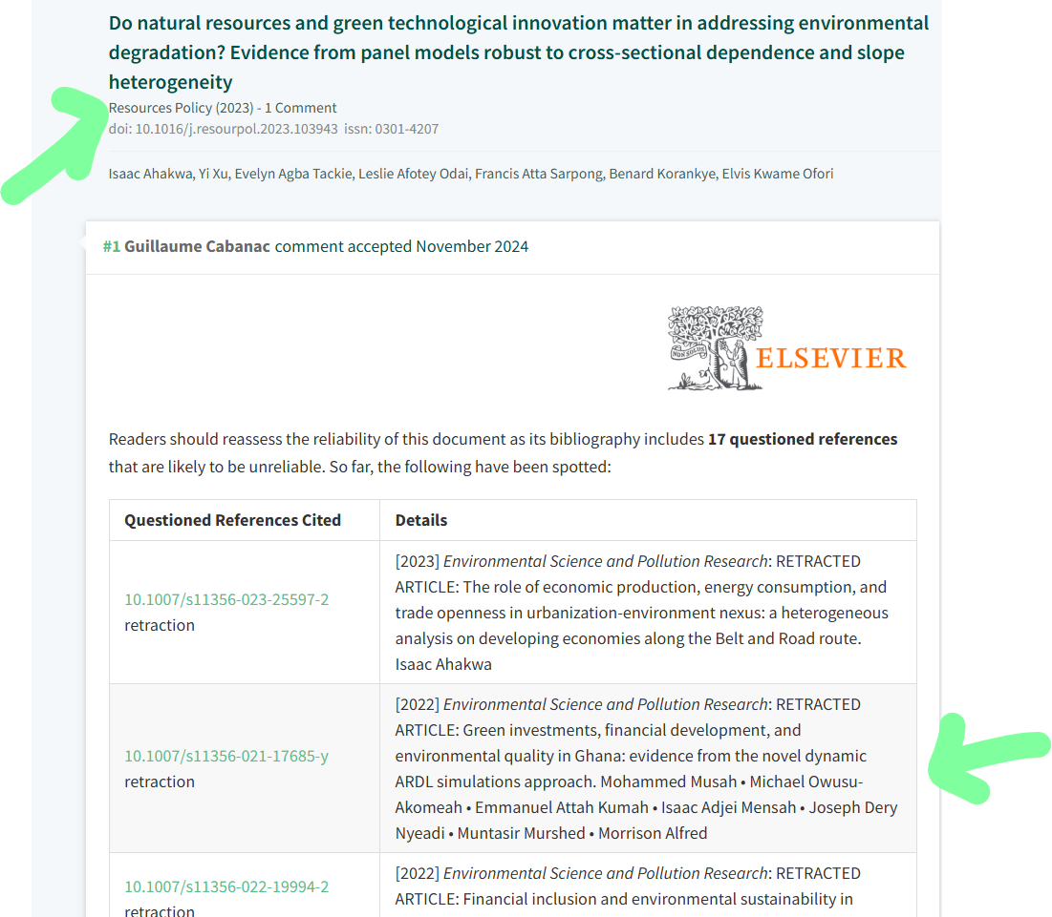

https://pubpeer.com/publications/466707D3DF2D81F7599755D8772E1D#0

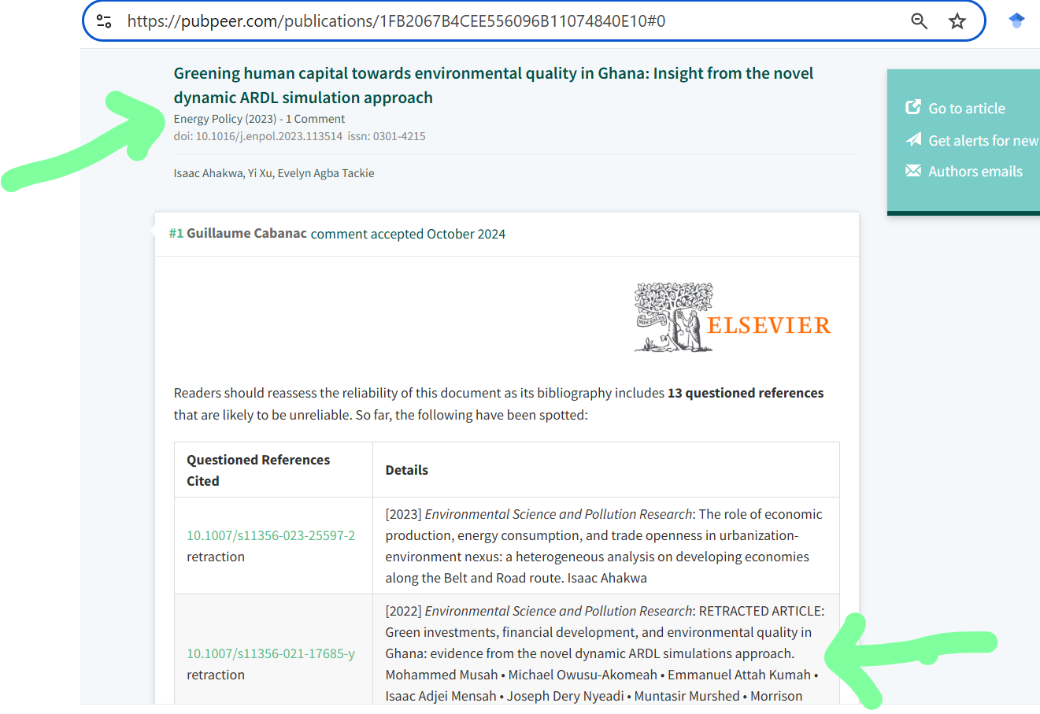

https://pubpeer.com/publications/1FB2067B4CEE556096B11074840E10#0

